Script-Controlled ACL – Restrict Record Access Based on Field Value

Description :

This lab demonstrates the implementation of a script-based Access Control List (ACL) to control access to records based on specific conditions. In this scenario, access is limited to users from the EEE branch, allowing them to view only records where the Branch field is set to EEE. However, administrators are granted unrestricted access to all records.

Milestone-1 Creation of Users and Roles

User Creation:
- Log in to the ServiceNow instance with admin access.
- Create a test user:
  - Navigate to User Administration → Users
  - Click New
  - User ID: EEE User
  - First name: EEE
  - Last name: User
  - Email: eeeuser@gmail.com
  - Save the record
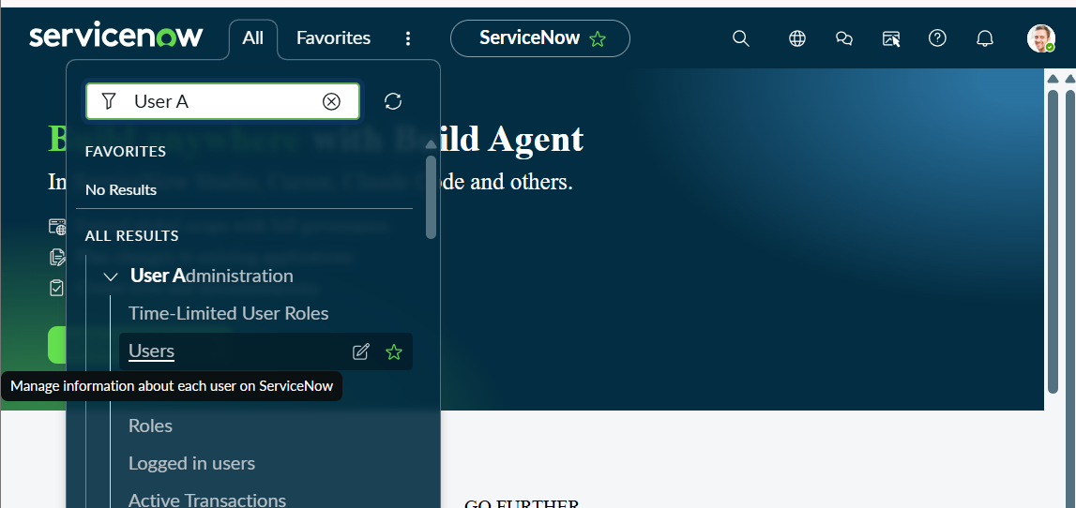
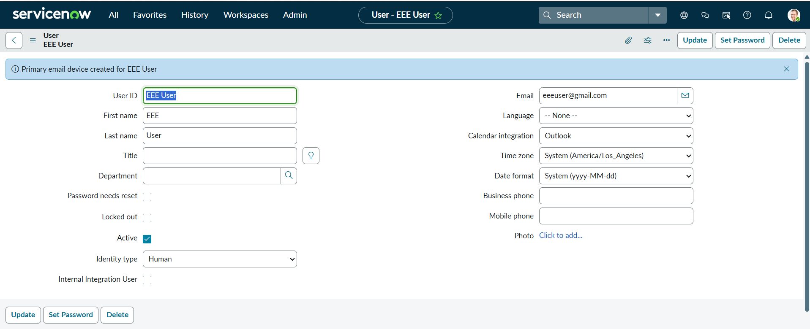

Role Creation:
- Navigate to User Administration → Roles
- Click New
- Name: Enter role name as bb1
- Description: Brief role purpose
- Click Submit
- Create other roles also like bb2,bb3,bb4.(follow the same procedure)
- Assign all the roles to the EEE User
